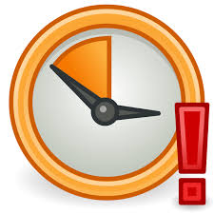

PLEASE CANCEL YOUR
APPOINTMENT IF YOU
DON’T NEED IT ANY LONGER

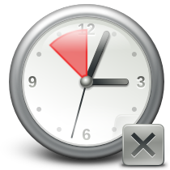

PRACTICE DID NOT ATTEND POLICY
PATIENT INFORMATION LEAFLET

You can cancel your appointment in different ways,

- Phone (01543 576660)
- Email (gp.suite@nhs.net)
- Patient Access (patient.emisaccess.co.uk)

Direct Web Address Through practice
(patient.emisaccess.co.uk) website link

Send a message Send a message

Select
‘cancel appointment booked’
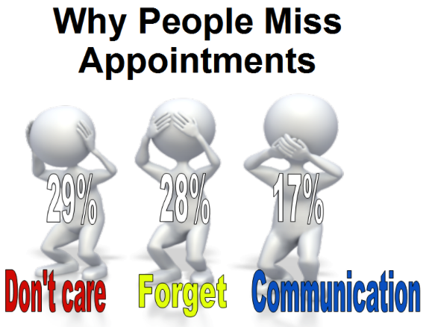

DUE TO THE NUMBER OF PATIENTS
FAILING TO ATTEND APPOINTMENTS, IT
MAY BE THAT YOU ARE NOT BE ABLE
TO SEE THE DOCTOR ON THE DAY
THAT YOU WISH TO.

IN AN ATTEMPT TO TRY AND RESOLVE
THIS, THE PRACTICE HAS DEVELOPED THE FOLLOWING POLICY.

IF YOU FAIL TO ATTEND APPOINTMENTS WITHOUT INFORMING US, WE WILL WRITE TO YOU ASKING IF THERE ARE ANY SPECIFIC PROBLEMS PREVENTING YOU FROM LETTING US KNOW.

IF YOU REPEATEDLY FAIL TO ATTEND FOR APPOINTMENTS, YOU MAY BE REMOVED FROM THE PRACTICE LIST AND HAVE TO FIND AN
ALTERNATIVE GP PRACTICE.

Thank you for your co-operation

